Project Design Phase
Problem – Solution Fit Template

Date | 18 Feb 2026
Team ID | LTVIP2026TMIDS80588
Project Name | TransLingua: AI-Powered Multi-Language Translator
Maximum Marks | 2 Marks

Problem – Solution Fit Template:
The Problem-Solution Fit simply means that you have found a problem with your customer and that the solution you have realized for it actually solves the customer’s problem. It helps entrepreneurs, marketers and corporate innovators identify behavioral patterns and recognize what would work and why
Purpose:
- Solving Complex Problems: We addressed the complex issue of "locked" information in foreign PDFs and images by integrating Multimodal AI (Gemini 3 Flash), allowing users to access data that was previously unreachable.
- Tapping into Existing Channels: By building the solution on a web-based Streamlit dashboard, we tap into the existing behavior of students and travelers who use browsers as their primary tool for information seeking.
- Building Trust: We solve the "urgent and costly" problem of manual translation errors and high-latency processing, building user trust through high-speed, context-aware accuracy.
- Understanding the Situation: By analyzing the frustrations of research students (manual copy-pasting) and travelers (unreadable signs), we improved the existing situation through automated OCR and translation.

Template:
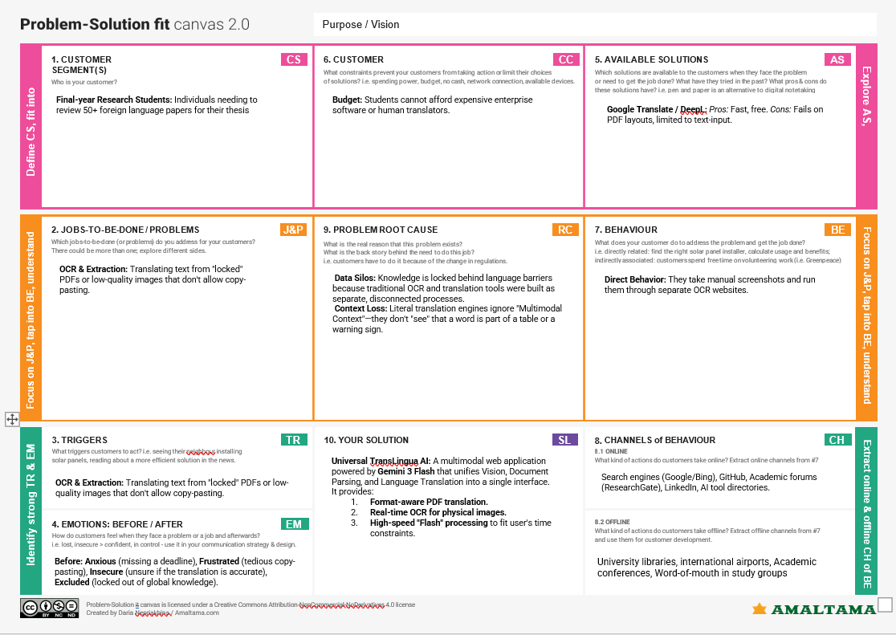
References:
- https://www.ideahackers.network/problem-solution-fit-canvas/
- https://medium.com/@epicantus/problem-solution-fit-canvas-aa3dd59cb4fe

